IS 340 Operating Systems

**HP04C Installing Ubuntu Desktop on VirtualBox**

07/10/2019 Developed by Kevin Kuanting Chen

07/16/2019 Reviewed by Apiwat Chuaphan and Clark Ngo

06/17/2020 Reviewed by Kim Nguyen

Center for Information Assurance Education (CIAE) @City University of Seattle (CityU)

|  |  |
| --- | --- |
| C:\Users\chungsam\AppData\Local\Microsoft\Windows\INetCache\Content.MSO\C47DD46.tmp | C:\Users\chungsam\AppData\Local\Microsoft\Windows\INetCache\Content.MSO\A00F4BF2.tmp |

**Installing Ubuntu Desktop on Virtual Box**

1. Download Ubuntu
   1. Visit <https://ubuntu.com/download> and press Ubuntu Desktop.

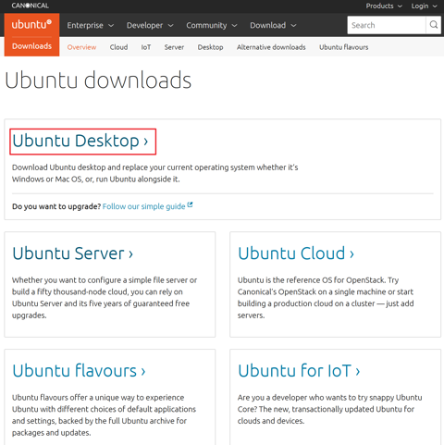

* 1. Press Download to download the latest Ubuntu Desktop LTS version.

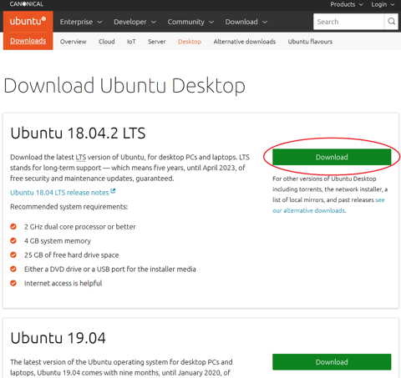

1. Create a Virtual Machine for Ubuntu.
   1. Open Oracle VM VirtualBox.
   2. Click New.

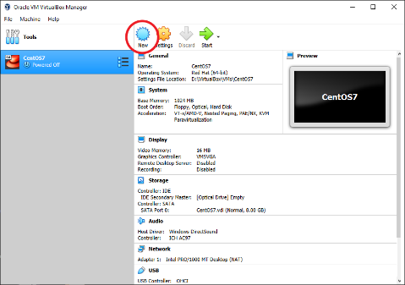

* 1. Fill in “Ubuntu18LTS” as the name and select a folder for the virtual machine. LTS is an abbreviation for “Long Term Support”.

Select Linux type and Ubuntu (64-bit) version and press Next.

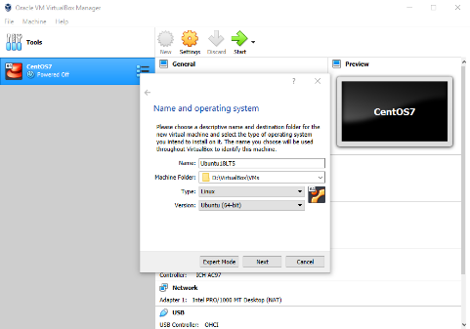

* 1. Allocate a memory size for the Virtual Machine. Set the memory size to 2048 MB. You can do more if your device has enough RAM. Then, press next.

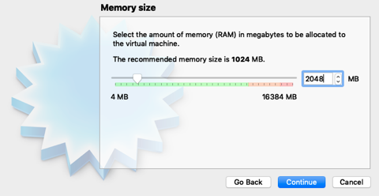

* 1. Make sure that Create a virtual hard disk now is selected. Press Create on the Hard disk page.
  2. Make sure that VDI is selected. Press Next on the Hard disk file type page.
  3. Make sure that Dynamically allocated is selected. Press Next on the Storage on physical hard disk page
  4. Check the file location and press Create on the File location and size page.
  5. In Oracle VM VirtualBox Manager, click on Ubuntu18LTS on the left to highlight it. Select settings.

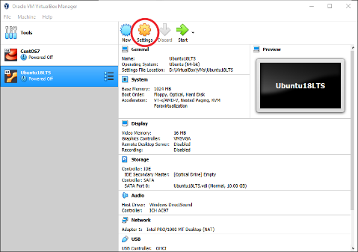

* 1. In the Ubuntu18LTS - Settings panel, go to Storage and highlight Empty in Storage Devices. Then, click on the disk icon in Attributes. Then, select Choose Virtual Optical Disk File.

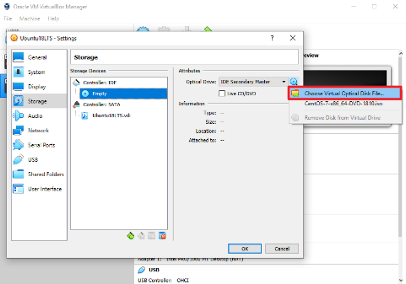

* 1. Open the Ubuntu ISO file you downloaded and press OK to leave the settings pane.

1. Install and configure Ubuntu.
2. Press Start to start Ubuntu.



1. Press Install Ubuntu.

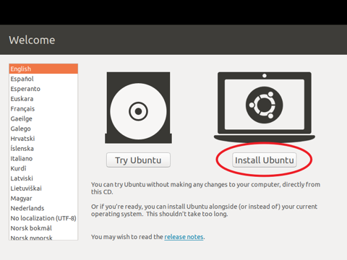

1. Press Continue on the Keyboard layout page.
2. Press Continue on the Updates and other software page.
3. Press Install Now on the Installation type page and press Continue.
4. On the Where are you page, select the West Coast and press Continue.

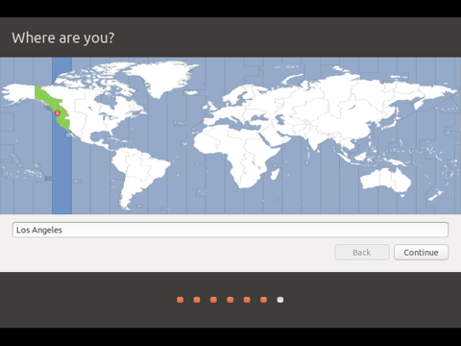

1. Finish the “Who are you?” page and press Continue.

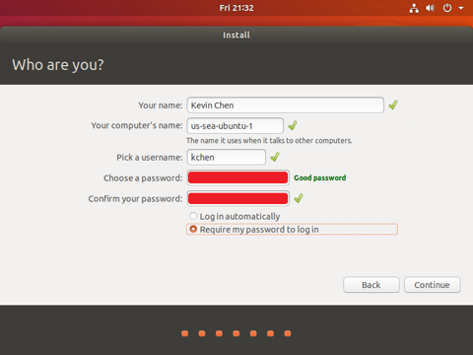

1. When Installation Complete, press Restart Now.
2. When it shows “Please remove the installation medium, then press ENTER:”, switch to the Oracle VM VirtualBox Manager window and press Settings.

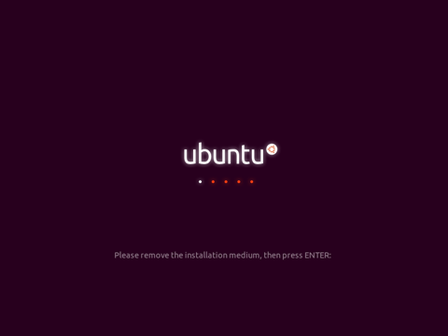

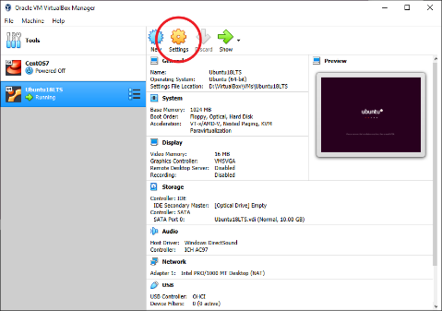

1. Navigate to Storage, check if it shows Empty under Controller: IDE. If not, highlight the disk you opened, press the disk icon on the right, and select Remove Disk from Virtual Drive. Press OK to leave the settings.

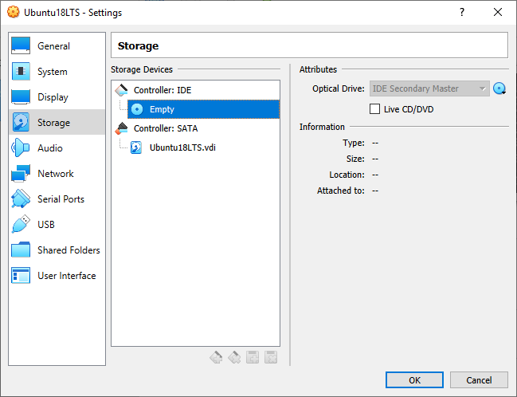

1. Switch back to the Ubuntu18LTS window and press enter.
2. You can select the account you created and enter the password to login.

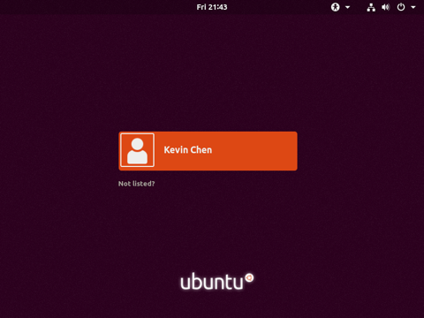

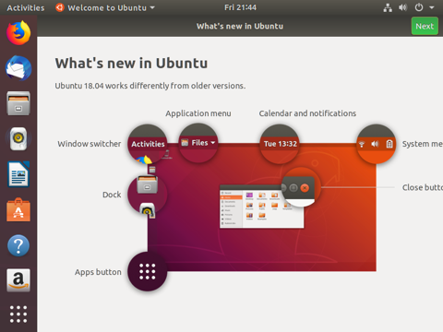

1. Exit your Ubuntu18LTS.  
   Click the red button on the top-left.

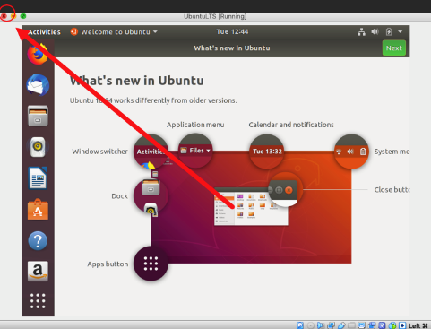

1. Choose Power off the machine and click OK

